PIZZA SALES QUERIES

# KPIs

## Total Revenue:

SELECT SUM(total_price) AS Total_Revenue from pizza_sales;

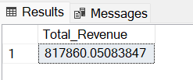

## Average Order Value:

SELECT SUM(total_price) / COUNT(DISTINCT order_id) AS Avg_Order_Value FROM pizza_sales;

## Total Pizzas Sold:

SELECT SUM(quantity) AS Total_Pizza_Sold FROM pizza_sales;

## Total Orders:

SELECT COUNT(DISTINCT order_id) AS Total_Orders FROM pizza_sales;

## Average Pizzas Per Order:

SELECT CAST(CAST (SUM(quantity) AS DECIMAL(10,2)) /

CAST (COUNT(DISTINCT order_id) AS DECIMAL(10,2)) AS DECIMAL(10,2))

AS Average_Pizzas_Per_Order FROM pizza_sales;

# CHART REQUIREMENT

## Daily Trend:

SELECT DATENAME (DW, order_date) AS order_day, COUNT(DISTINCT order_id) AS total_orders

FROM pizza_sales

GROUP BY DATENAME(DW, order_date);

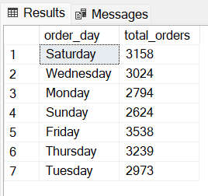

## Hourly Trend:

SELECT DATEPART(HOUR, order_time) AS order_hours, COUNT (DISTINCT order_id) AS total_orders

FROM pizza_sales

GROUP BY DATEPART(HOUR, order_time)

ORDER BY DATEPART(HOUR, order_time);

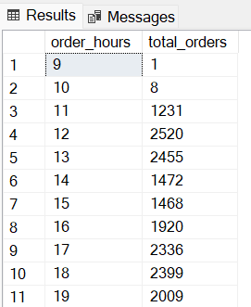

## Percentage Sales By Pizza Category:

SELECT pizza_category, SUM(total_price) * 100 / (SELECT SUM(total_price) FROM pizza_sales) AS

sales_percentage

FROM pizza_sales

GROUP BY pizza_category;

## Percentage Sales By Pizza Category (Month wise):

Month December (12) taken for example,

SELECT pizza_category, SUM(total_price) * 100 / (SELECT SUM(total_price) FROM pizza_sales WHERE MONTH(order_date) = 1) AS sales_percentage

FROM pizza_sales

WHERE MONTH(order_date) = 12

GROUP BY pizza_category;

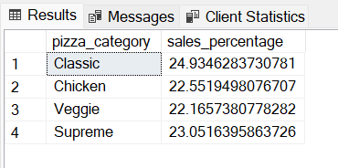

## Percentage Sales By Pizza Size:

SELECT pizza_size, SUM(total_price) * 100 / (SELECT SUM(total_price) FROM pizza_sales) AS sales_percentage

FROM pizza_sales

GROUP BY pizza_size;

## Total Pizza Sold By Pizza Category:

SELECT pizza_category, SUM(quantity) AS total_pizza_sold

FROM pizza_sales

GROUP BY pizza_category

ORDER BY total_pizza_sold DESC;

## Top 5 Best Sellers:

SELECT TOP 5 pizza_name, SUM(quantity) AS total_pizza_sold

FROM pizza_sales

GROUP BY pizza_name

ORDER BY total_pizza_sold DESC;

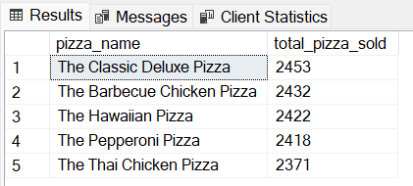

## Bottom 5 Worst Sellers:

SELECT TOP 5 pizza_name, SUM(quantity) AS total_pizza_sold

FROM pizza_sales

GROUP BY pizza_name

ORDER BY total_pizza_sold;

